Everyday CoJourner

Step 3 Session Notes



THIS TRAINING FOLLOWS CRU’S SENT:67, A PROCESS TO EQUIP PEOPLE TO INITIATE, BUILD AND MULTIPLY THE LOCAL CHURCH, FAITH COMMUNITIES & DISCIPLESHIP GROUPS, SO THAT EVERY FOLLOWER OF JESUS HAS A PLACE FOR CONNECTION, GROWTH AND EQUIPPING. THIS IS VITAL FOR THE VISION OF EVERYONE KNOWING SOMEONE WHO TRULY FOLLOWS JESUS.

### 

### 

### 

### 

### 

## 

#### 

### PROCESS OF SENT 6:7

***Sent 6:7*** steps 1-4 is a process to equip leaders to initiate, build and multiply the local church, faith communities and discipleship groups.

Here is an overview of the ***Sent 6:7*** process (refer to chart on next page for more information):

* **Step 1:** ***Becoming a CoJourner*** training (a 2-3 hour session, plus three weeks of application)
* **Step 2:** A follow-up meeting of accountability and fellowship (a 1.5-hour session)
* **Step 3:** ***Evangelism Movements*** and ***Sent 6:7 PURSUE -*** *foundations for growth* training (3-4-hour session)
* **Step 4:** ***Sent 6:7 - LAUNCH*** - *preparing to lead* (11 sessions) and ***Sent 6:7 - DEVELOP*** - *peer-coaching among leaders* – a community for leadership development and missional effectiveness (12 sessions to be used in coaching circles and/or self-directed study)

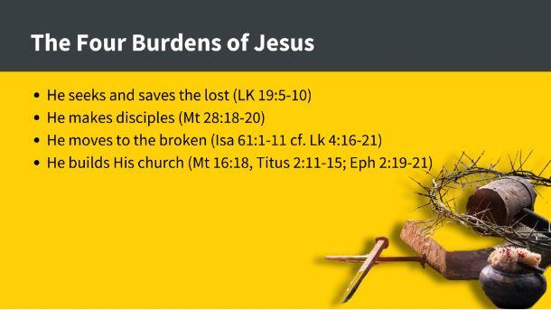

Other notes about recap

### 

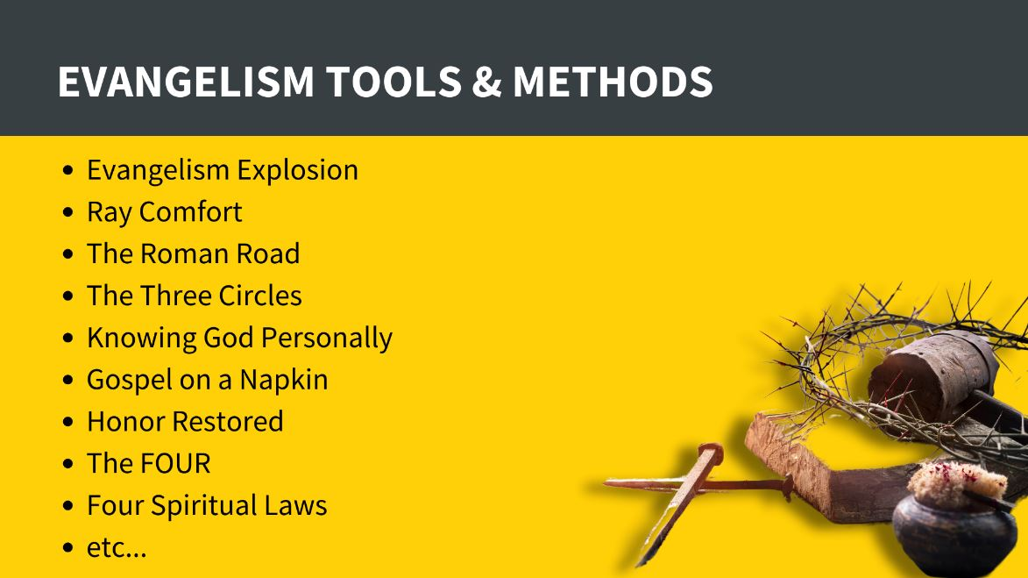

### 

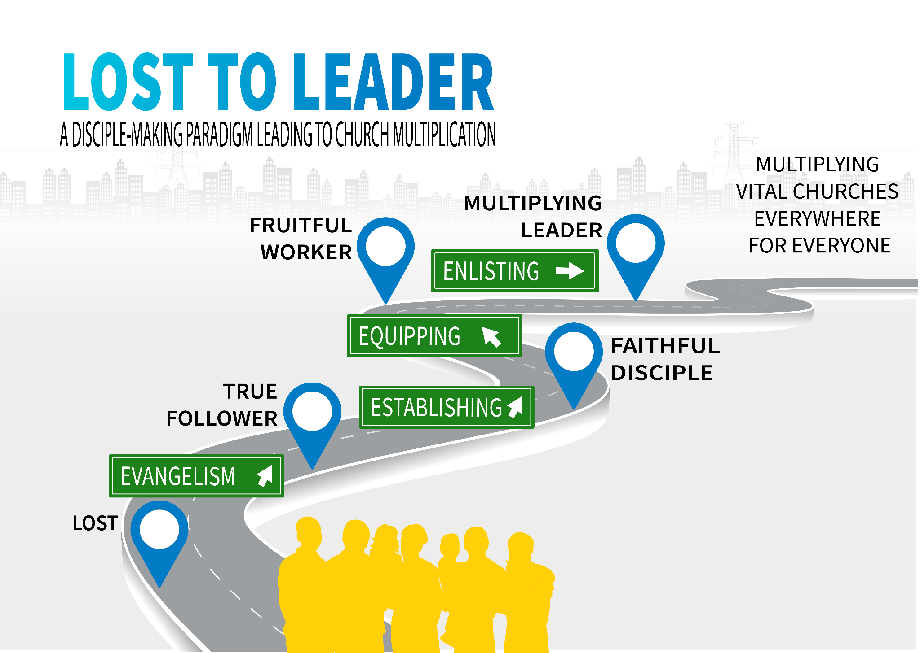

### 

# 

# God Prepared People

The purpose of this session is to gain an understanding of the principle of finding a person whom God has prepared—a person who bears fruit, who believes the gospel, perseveres, and reproduces. In other words, a God-Prepared Person is a Fourth-Soil Person. Each participant will describe the qualities of God-Prepared People, discuss how the CoJourner role of an Explorer will help to identify them, and explain the impact they can make in helping advance the mission of Jesus.

##### Breakout Activity #1: The Parable of the Sower (Luke 8:4-15)

* What caught your attention and why?
* What can we learn about God or people?

##### Jesus sends out the seventy-two (Luke 10:1-11)

##### Breakout Activity #2: Biblical Examples of God-Prepared People

A God-Prepared Person is a Fourth-Soil Person. As we look at these passages and stories, we will discover that they receive you and your message.

| Person | How would you describe this person? | What did this person do that makes them a God-Prepared Person/4th Soil Person? |
| --- | --- | --- |
| Samaritan woman  [John 4:1-42](https://arc.gt/7cks9) |  |  |
| Zacchaeus  [Luke 19:1-10](https://arc.gt/q5k4z) |  |  |
| Diana - [Panama](https://vimeo.com/253595998) video |  |  |

### 

(More about God-Prepared People in the Appendix.)

### Identifying God-Prepared People (Oikos list)

Write down the names of people with whom you can live the prayer-care-share lifestyle.

NB - Non-believer

NeB - New-believer

F - Follower

Can you identify a God-Prepared Person or someone who displays those characteristics?

| Names | NB | NeB | F |
| --- | --- | --- | --- |
|  |  |  |  |
|  |  |  |  |
|  |  |  |  |
|  |  |  |  |
|  |  |  |  |
|  |  |  |  |
|  |  |  |  |
|  |  |  |  |
|  |  |  |  |
|  |  |  |  |
|  |  |  |  |

##### Bless Every Home - start practicing the Prayer-Care-Share lifestyle in your neighborhood

##### 

##### 

www.blesseveryhome.com

# Disciple-making Pathway

##### What to do when someone says “Yes”?

##### 

##### Environment

##### Process

##### Content

##### 

##### What is needed for fruitful disciple-making?

##### The Five Essentials of a Disciple-Making Culture

1. A Relationship of love and influence
2. The ones who teach, model, and coach
3. A call to faith, action, challenge, and empowerment
4. It moves to those far from God
5. Engaged in church and kingdom-community

##### Simple Environment (Prayer-Care-Share Relationships)

##### Simple Process (3/3 methods)

##### Simple Content (DBS / i.e., Sent 6:7)______________________

##### Transferability & Multiplication

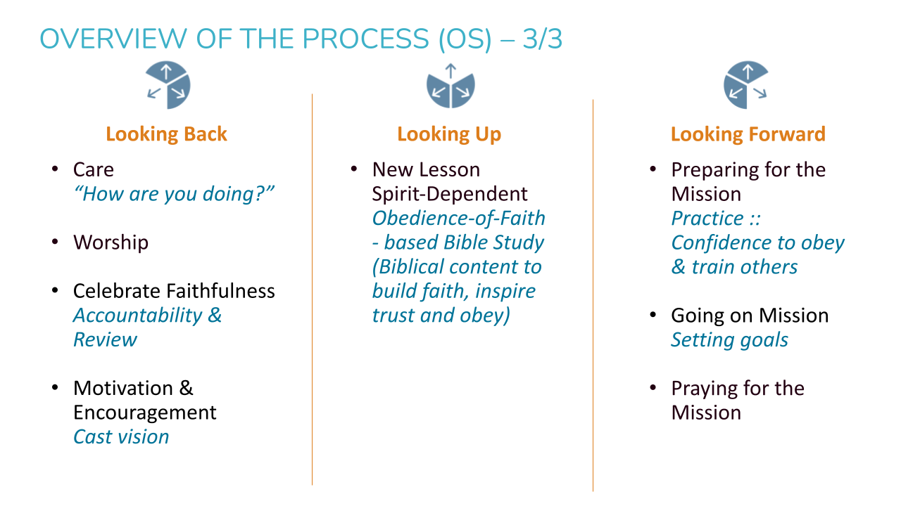

##### How do the parts work together?

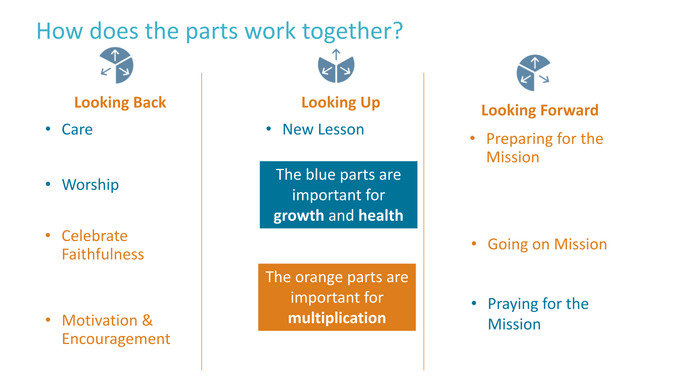

##### Breakout Activity #3

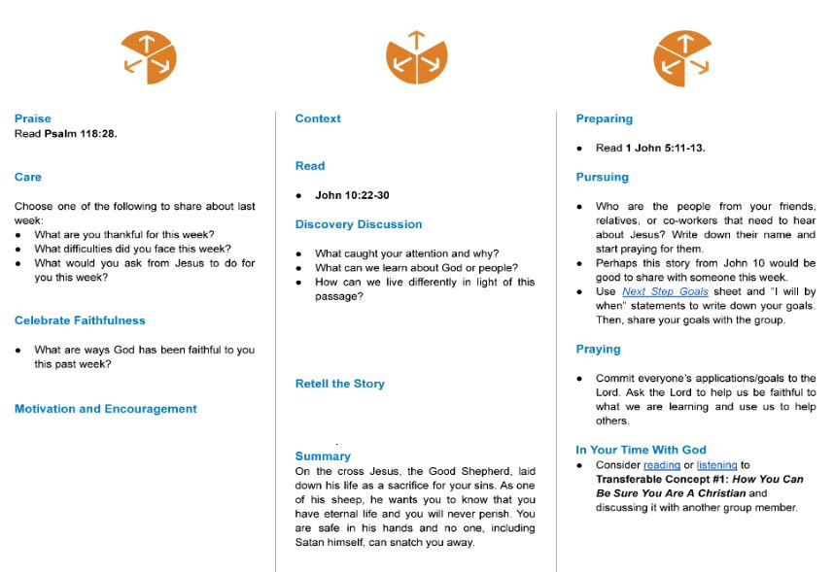

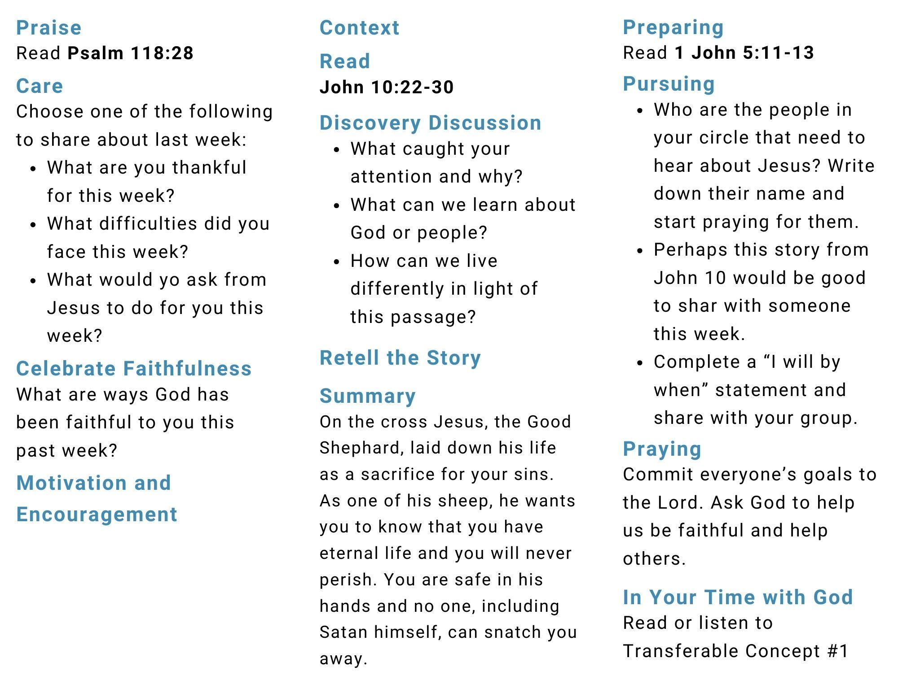

##### Concluding Notes

Appendix

# The Difference between a Person of Peace and God-Prepared People (a 4th Soil Person)

### Characteristics of Person of Peace

As in Luke 10:1-11 - Jesus tells the disciples where to go, what to say, with whom to talk, what to watch out for, and what to do if their message is rejected. These detailed instructions do not represent the goal of the assignment: A harvest. The overarching mission involves broad seed-sowing throughout Galilee.

Jesus’ plan to care for the disciples as the “House rule” that provides a base of operation for fieldworkers assigned to unfamiliar mission fields - see Mark 10:6, Matthew 10:11, Luke 10:7

In other words, Jesus instructed His disciples to find a home base, then cease the search for more home bases. They were not to waste time looking for multiple homes while they sowed the area with the gospel. Is it possible for a Person of Peace to also be a Fourth-Soil Person? Certainly! When the area has been sown, travel to a new area and repeat the process; first find a Person of Peace, then again saturate the area with the gospel.

They are...

* Hospitable
* Generous
* Agreeable
* Open

Finding a Person of Peace helps you target your ministry area.

### Characteristics of God-Prepared People/Fourth-Soil People

Lydia (Acts 16:14-15), the Philippian jailer (Acts 16:25-34) and Matthew the tax collector (Matthew 9:9-10)

Each of these individuals becomes a believer and reproduces.

They represent a profile of the Fourth-Soil Person mentioned in the Parable of the Sower. According to the Parable of the Sower, a Fourth-Soil Person includes the following: believes the gospel, perseveres and reproduces even when passing through a time of testing (i.e., threat of persecution), and reproduces regardless of the threat and distractions of worry, riches, and pleasures of life.

Jesus provides additional information by describing the Fourth-Soil Person as a generous or hospitable person who reproduces (i.e., sees people come to know Jesus and makes new disciples) at a pace of thirtyfold, sixtyfold, or a hundredfold.

Sowers do not make Fourth-Soil People; they find them through seed-sowing. People often ask me how to transform second- and third-soil people into Fourth-Soil People. Although this is a possibility, remember Jesus’ Parable of the Growing Seed (Mark 4:30–32; Mark places this parable after the Parable of the Sower)—that our assignment is only to sow and reap a harvest. Efforts to transform second- and third-soil people into Fourth-Soil People should not replace broad seed-sowing efforts to find Fourth-Soil People in the harvest fields.

They...

* Are generous
* Open their relational networks
* Win their household, connect the disciples to the community, and start a movement in the community, as seen in Scriptural examples.
* Are Movement-Catalysts

### Questions for Discussion

1. After reading this, how would you explain the difference between the Person of Peace and the Fourth-Soil Person?
2. The Fourth-Soil Person multiplies through the oikos (household) principle.
3. How would you describe that in our modern world? What is our oikos?
4. How can you imagine this principle leading to movements?

# Bookmarks

### Stories of Hope

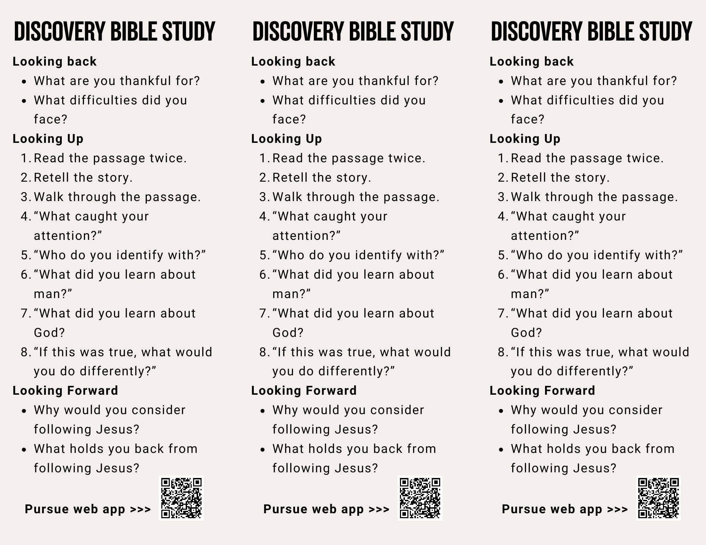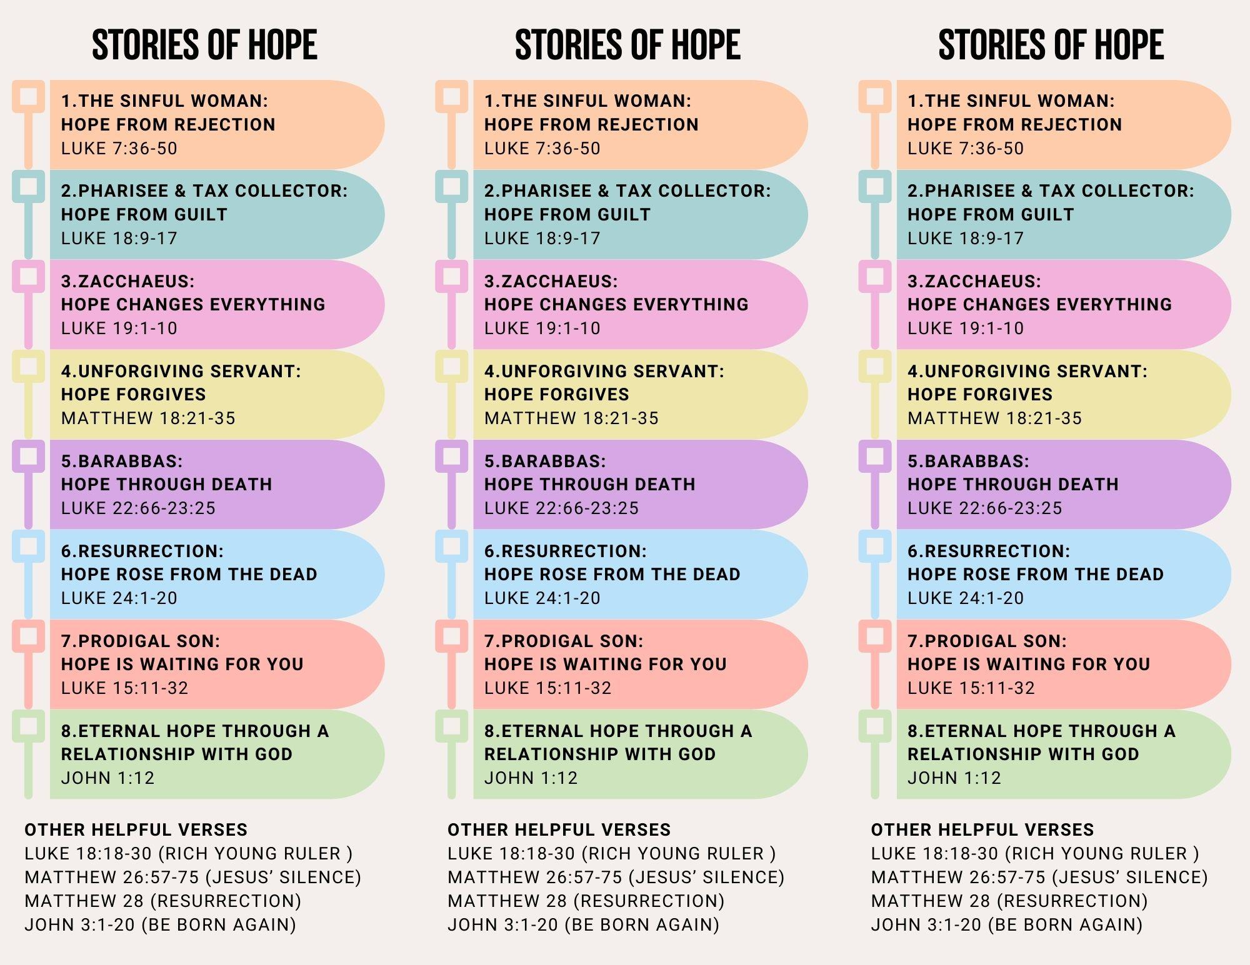

### Foundations for Growth

