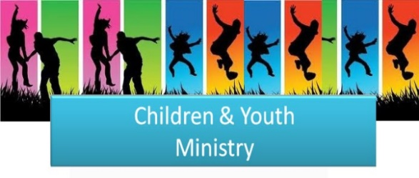
We are excited to share our Fall 2020 program details with you! Please follow the included links to register your child for activities and to sign up for text alerts to be aware of events and changes.

Send questions to our Youth Director, Bethany Carl at bethany@medfordumc.org.

Sunday School for Students in Pre-K through 5th Grade
Our students and teachers will participate in a Zoom Gathering on the first Sunday of each month at 10:30 am. Pre-recorded Sunday School lessons will be posted on the Medford UMC YouTube channel each Saturday. You may access these at your convenience. Email Bethany to request age-appropriate activity sheets and a Family Activity Book.
- A registration form must be completed for each child – click here to complete the quick form.
- Sunday School Zoom Sessions can be accessed here on November 1 & December 6 at 10:30 am.
- Weekly resources can be found on our YouTube channel beginning October 10.
- Stay up-to-date with schedules and reminders by signing up for our Sunday School Text Alerts.

Youth Fellowship and Faith Formation Groups
Third through Fifth Grade Kids’ Group
Children in third, fourth and fifth grades are invited to participate on Sunday mornings at 10:30 am in special Zoom gatherings. The first Sunday of each month will be Sunday School. Other Sundays will include opportunities to play games and form friendships.
Sixth and Seventh Grade Pre-Confirmation Fellowship and Faith Formation
Preteens will have three in-person gatherings this fall. All sessions will be outdoors and follow appropriate safety measures. These sessions will include opportunities to get to know one another, play games and for light faith exploration. Our next Zoom gathering is October 11 at 11:30 am.
Eighth Grade Confirmation
Confirmation is a chance for teens to dig deep into their relationships with God and with the church. Fall will be a time of preparation -- the eighth graders will to get to know each other and their adult mentors. We will have three in-person gatherings this fall. All sessions will be outdoors and follow appropriate safety measures. These sessions will include opportunities to get to know one another, play games and for beginning the Confirmation discussion. Join our Zoom gathering on October 11 at noon.
High School Small Group
High School students will gather every other week (virtually and in-person) for a time to continue connections with peers and adults, to remember that our faith family is available for support and to learn to apply faith to their everyday lives. Join our Zoom gathering on October 11 at 12:45 pm.
- Registration for 6th through 12th graders is available through this link. Kids’ Group registration is part of the Sunday School registration process.
- Stay up-to-date with schedules and reminders by signing up for our Youth Fellowship Text Alerts.

