Thanksgiving Meal Donation Bags

MDUMC Information Sheet
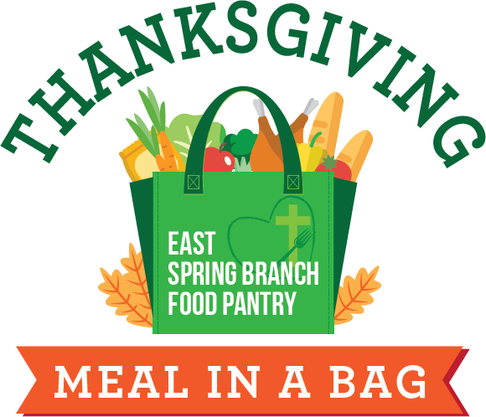

Thank you for supporting the East Spring Branch Food Pantry Thanksgiving Meal distribution. Each bag will be supplemented with a turkey and fresh produce.
Meal bags will be distributed to families in Spring Branch ISD.

Please purchase requested items, fill the bag, and return the filled bags to either MDUMC campus by Sunday, November 16.

Please ﬁll bag with only the items, quantities and sizes requested:

1 CAN (14 OZ.) GREEN BEANS | 1 (1 LB.) BAG RICE | 1 (6 OZ.) PKG. JELLO
1 CAN (14 OZ.) CORN | 1 (1 LB.) BAG DRIED BEANS | 1 (14 OZ.) CAN YAMS
1 CAN (14 OZ.) TOMATOES | 1 PKG. CORNBREAD MIX | 1 (6 OZ) PKG. STUFFING MIX
1 CAN (14 OZ.) CHICKEN BROTH | 1 BOX CAKE MIX and FROSTING | 1 (16 OZ.) PKG PASTA
1 CAN (14 OZ.) FRUIT COCKTAIL | 1 CAN (14 OZ.) CRANBERRY SAUCE

