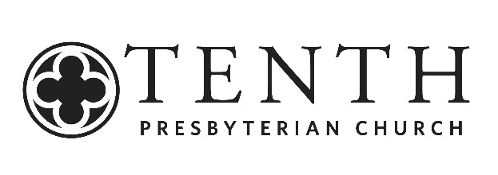
New Members Class
Fall 2021 SCHEDULE and vows

Date | Topic
October 3 | Introduction  The Gospel
October 10 | The Doctrines of Grace
October 17 | Worship & Preaching
October 24 | Sacraments  *Written Testimonies due
October 31 | Church Government & Discipline
November 7 | The Church & Community Life
November 14 | Spiritual Gifts
November 21 | Service & Stewardship
December 5 | Interviews
December 12 | Reception
The course modules are organized in such a way as to address the vows of membership. Those questions are:
- Do you acknowledge yourselves to be sinners in the sight of God, justly deserving His displeasure, and without hope save in His sovereign mercy?
- Do you believe in the Lord Jesus Christ as the Son of God, and Savior of sinners, and do you receive and rest upon Him alone for salvation as He is offered in the Gospel?
- Do you now resolve and promise, in humble reliance upon the grace of the Holy Spirit, that you will endeavor to live as becomes the followers of Christ?
- Do you promise to support the Church in its worship and work to the best of your ability?
- Do you submit yourselves to the government and discipline of the Church, and promise to study its purity and peace?

Carroll Wynne is our class coordinator. cwynne@tenth.org.

